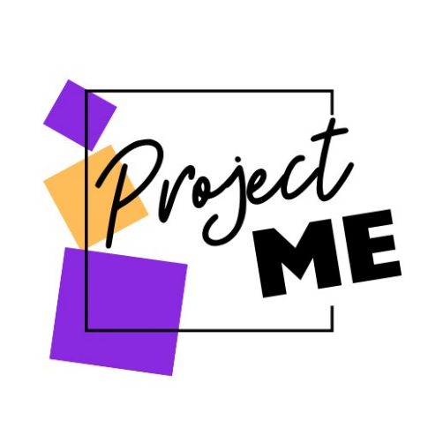

Health and Safety Policy
Last Reviewed: 25th August 2023
Date of Upcoming Review: 25th August 2024
Purpose
The purpose of this Health and Safety Policy is to establish guidelines and procedures to ensure the health, safety, and wellbeing of all individuals involved in the operations of ProjectMe. As a company dedicated to providing social skills, emotional regulation, and mental health support to children in schools and private settings, ProjectMe recognises the importance of maintaining a safe and healthy environment for both staff and clients.
Scope
This policy applies to all employees, contractors, volunteers, interns, and any other individuals representing ProjectMe in any capacity.
Responsibilities
a. Management: ProjectMe management is responsible for providing leadership and resources to implement and maintain effective health and safety measures.
b. Staff: All staff members are responsible for complying with health and safety policies and procedures, identifying and reporting hazards, and participating in training and awareness programs.
c. Clients: ProjectMe clients are responsible for following any safety instructions provided by staff members and reporting any concerns or hazards they observe.
Risk Assessment
a. ProjectMe will follow all risk assessment procedures as outlined by each school in which our sessions run. ProjectMe will conduct regular risk assessments of its equipment, and activities to identify potential hazards and implement appropriate control measures.
b. Risk assessments will be documented, reviewed periodically, and updated as necessary.
Safe Work Practices
a. Staff members must follow safe work practices and procedures at all times to minimise the risk of injury or harm to themselves, clients, and others.
b. This includes proper use of equipment, adherence to safety protocols, and maintaining a clean and organised work environment.
Emergency Preparedness
a. ProjectMe will be aware of and follow any emergency response plans to address potential emergencies such as fires, medical emergencies, or natural disasters at all schools in which they work.
b. Staff members will be informed on emergency procedures and evacuation protocols in all schools and private residences.
First Aid and Medical Assistance
a. ProjectMe will ensure they are aware of first aid trainers within schools they are working in and know where first aid supplies are readily available at all locations where services are provided. ProjectMe will be made aware of medical needs of any children they are working with at school or at home. In private residences, parents/carers are expected to provide first aid if needed.Hygiene and Sanitation
a. ProjectMe will maintain high standards of hygiene and sanitation to prevent the spread of illness and infection.
b. This includes cleaning of facilities, equipment, and commonly touched surfaces. Schools are responsible for ensuring regular cleaning of areas used by ProjectMe. Parents/carers are responsible for ensuring regular cleaning of areas used by ProjectMe in private residences.

Health Promotion
a. ProjectMe will promote health and wellbeing among staff and clients through education, awareness campaigns, and access to resources and support services.
b. This may include providing information on nutrition, physical activity, stress management, and mental health.
Compliance with Regulations
a. ProjectMe will comply with all relevant health and safety regulations and standards applicable to its operations and will do this in line with health and safety policies set out by the schools with which we work.
b. Management will stay informed about changes to regulations and ensure that policies and procedures are updated accordingly.
Training and Education
a. ProjectMe will provide training and education to staff members on health and safety topics relevant to their roles and responsibilities.
b. Training may include but is not limited to, hazard identification, emergency response, first aid, and infection control.
Communication and Consultation
a. ProjectMe will communicate health and safety policies, procedures, and information to staff, clients, and other stakeholders through various channels.
b. Staff members will be encouraged to participate in the development and review of health and safety measures and to raise any concerns or suggestions for improvement.
Review and Revision
a. This Health and Safety Policy will be reviewed periodically to ensure its effectiveness and compliance with relevant laws and regulations.
b. Any necessary revisions will be made in consultation with legal advisors, health and safety experts, and relevant stakeholders.

Conclusion
ProjectMe is committed to providing a safe and healthy environment for all individuals involved in its operations. This Health and Safety Policy reflects our dedication to protecting the wellbeing of our staff, clients, and communities and to promoting a culture of safety and wellness in everything we do.

